Resilience Toolkit How to Guide

Getting Started
- Open your web browser and navigate to https://resilientmaryland.com
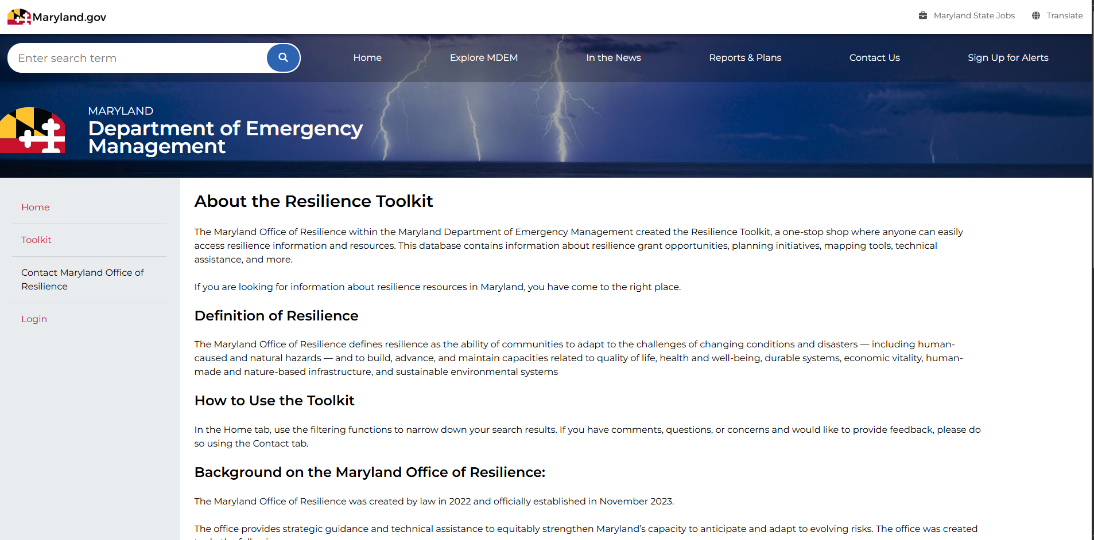

- The main search features of the site are accessible without logging in credentials. For specific non-public users, the Login option on the left-hand side will allow access to additional features.
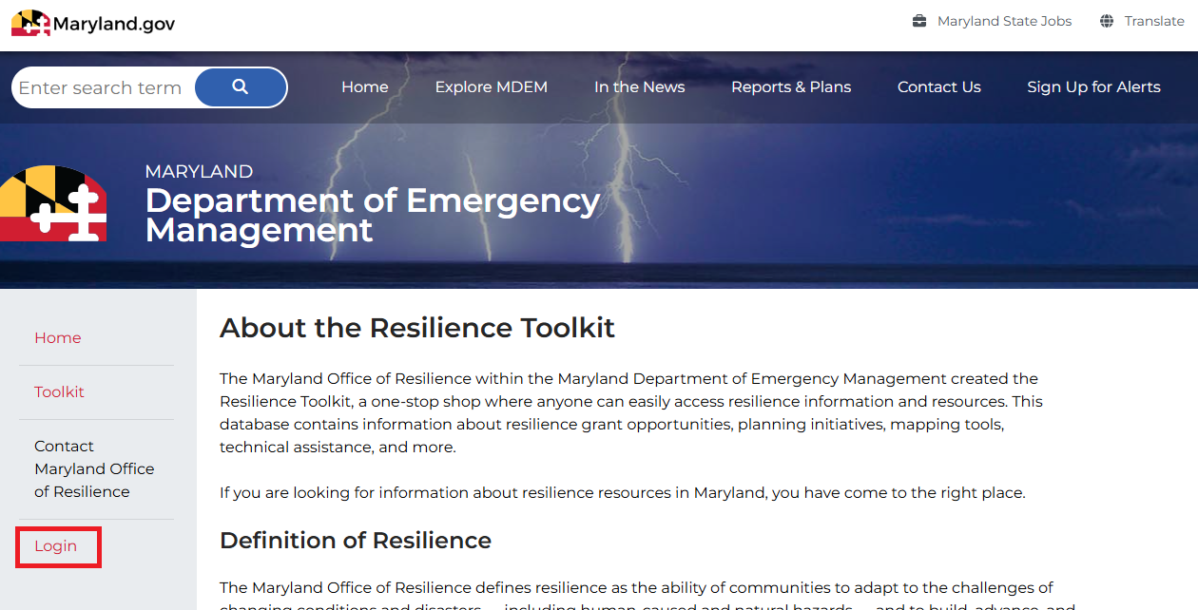

Navigating the Toolkit
- On the left sidebar, click the Toolkit option. You will be directed to the Toolkit page. This page has multiple empty fields that will be used to navigate.
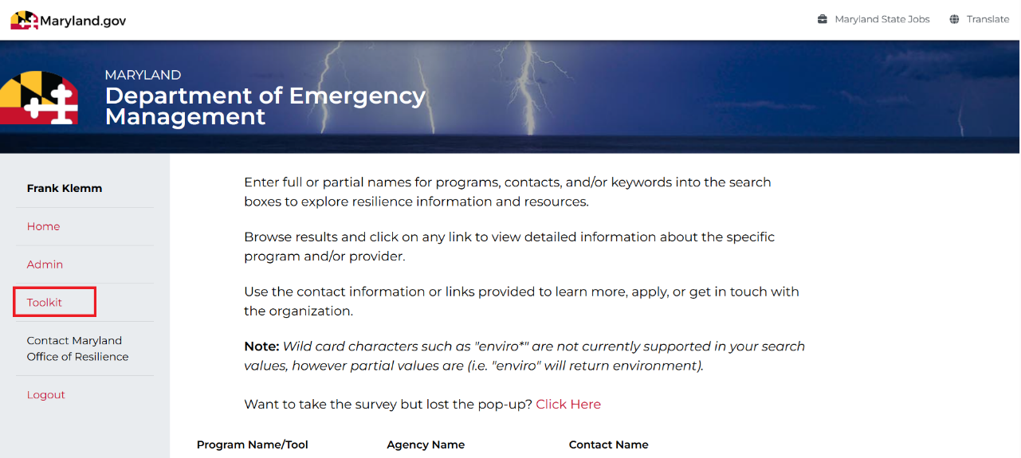

- The page may open with a welcome message that describes the toolkit as your centralized gateway for grants, planning support, mapping tools, and technical assistance statewide. You can press Close to exit out of this screen.
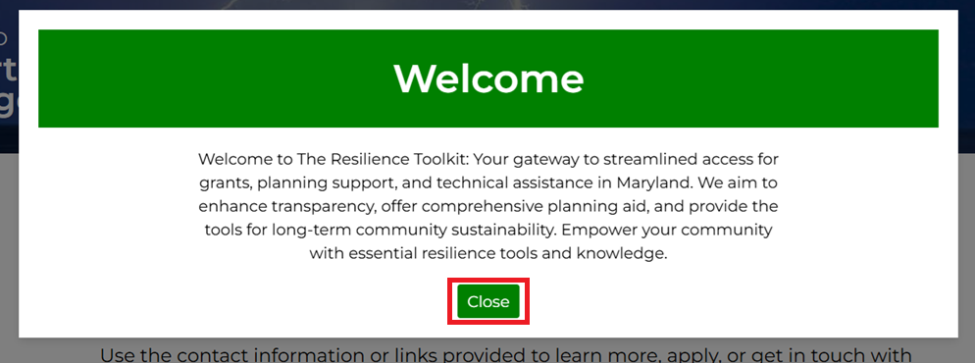
- The search features include filterable fields, such as:
  - Program Name: Name of the grant program or tool of interest
  - Agency Name: Agency/organization responsible for issuing or administering the grant program or relevant tool
  - Due Date (grants/loans only): Deadline for submission of applications
  - Keywords: Terms used in the cost share description of the item
  - Funding Type (grants/loans only): Grant or loan funding source

- Enter your desired search criteria, then click the Search button (highlighted in red below). The results will appear as shown in a green grid below.
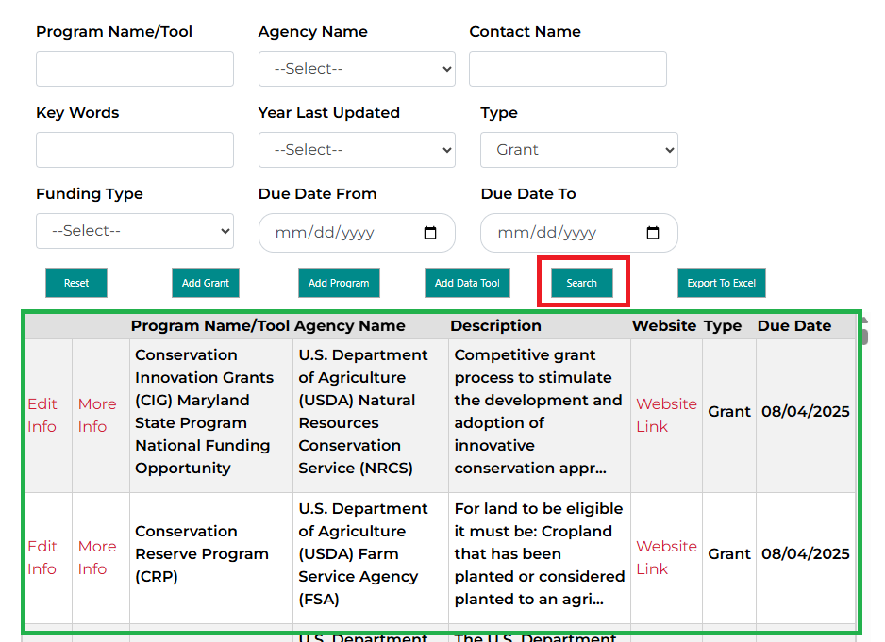
  - Once the search grid is generated, there will be an option to export the search results to an Excel file. This can be done by pressing the Export to Excel button. This feature and a sample of the results are shown below.
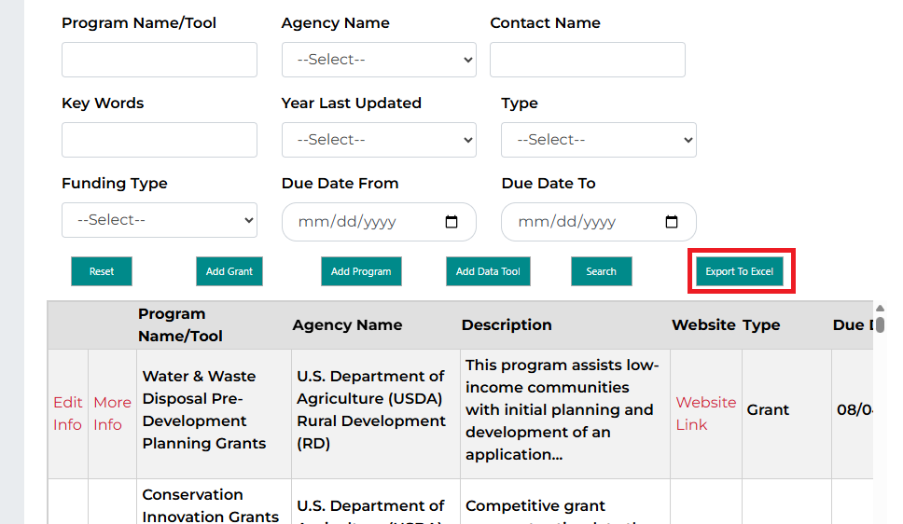
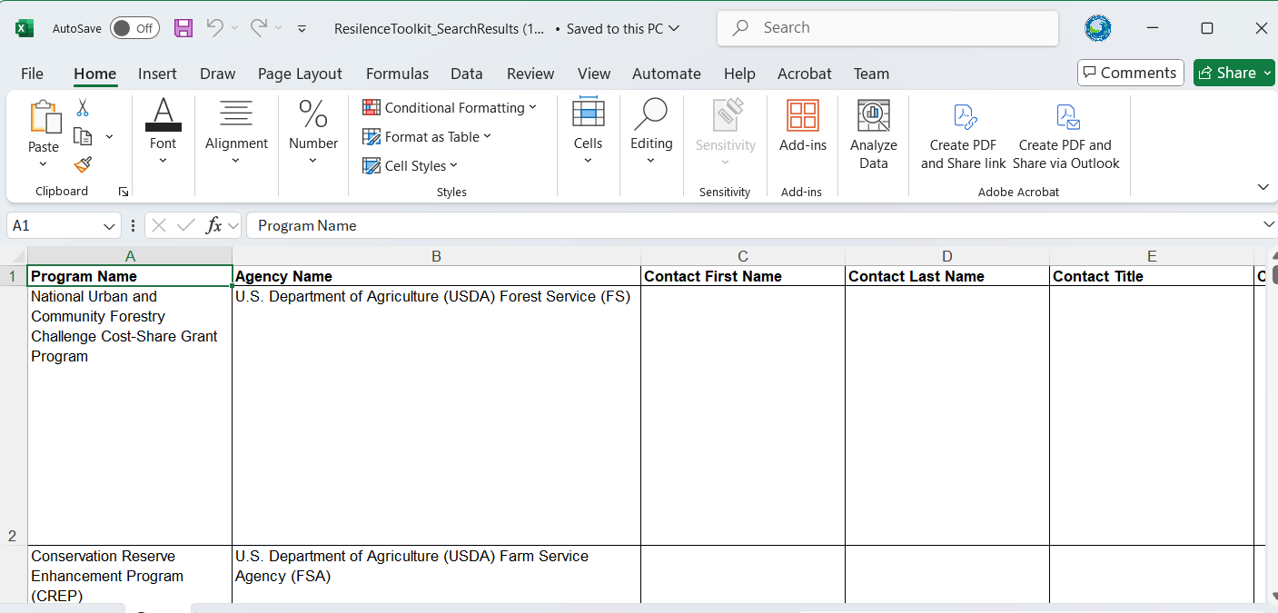
  - Click Reset to clear the search grid.
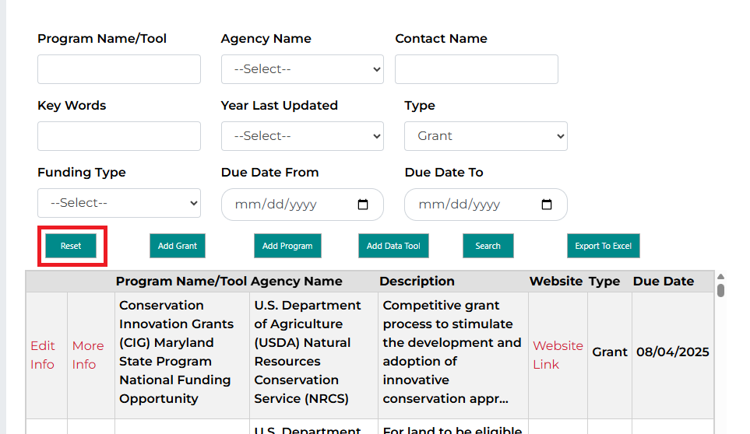
- Logged-in users may add or edit grant information directly on the website. Select the Add Grant button at the bottom of the screen to enter new information.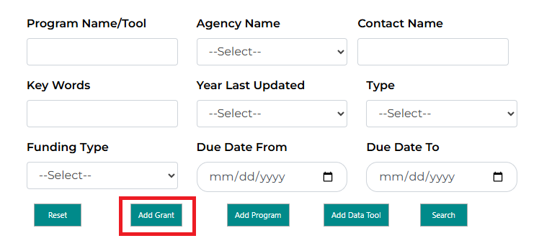
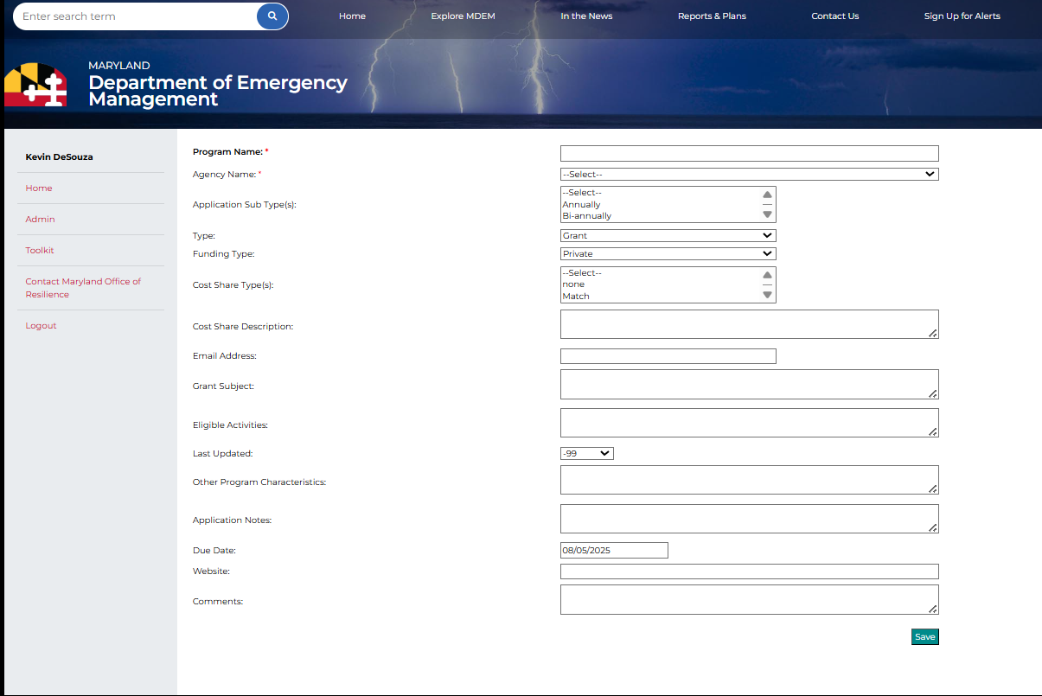Fields that are required will be marked with a red asterisk “*”
- In addition to the Add Grant button, there are other options to add programs and Data Tools (Add Program, Add Data Tool) which allow users to add records in a similar way to the Add Grant page.
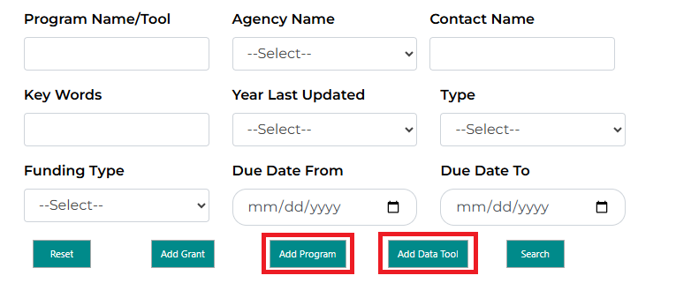
- Logged-in users can also edit records within their own organization, while MDEM accounts may add and edit records for any agency.
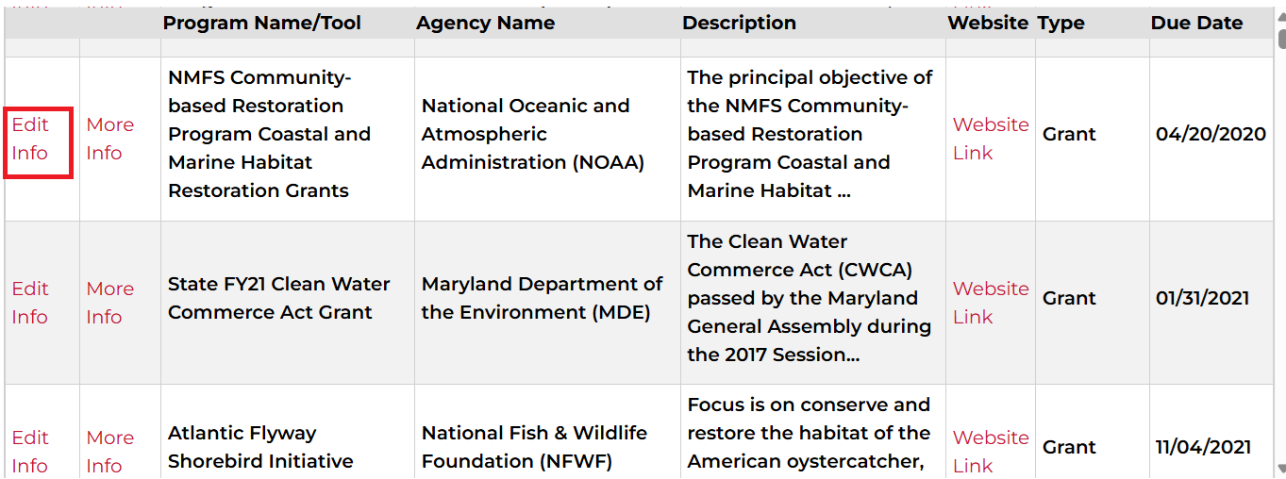

Providing Feedback
Users can provide feedback by selecting the Contact tab, located either in the left sidebar or at the bottom of the Toolkit site. This feedback can be in the form of questions, suggestions, technical issues or bug reports.
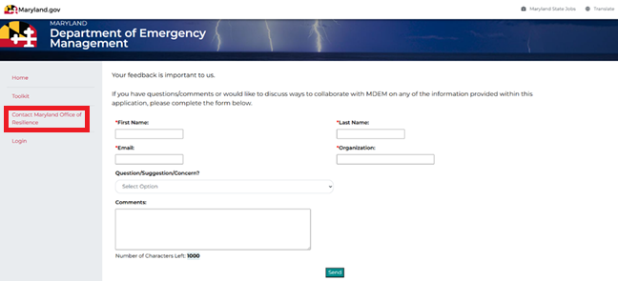

Data Definitions
There are three possible form types: grants (including loans), programs (including technical assistance), and data (tools and toolkits).

Each of the forms has multiple items to be filled out, as listed below:

Grants Form

Program Name (required): Official name of the grant program.

Agency Name (required): Agency or organization responsible for issuing or administering the grant program.

Application Sub Type(s): Multiple values may be selected. These are generally time-based (e.g., annual) but may also include non-time-based options such as emergency.

Type: Used to specify if the opportunity is a grant and/or loan.

Funding Type: Grant or loan funding source. This includes private, non-profit and numerous jurisdiction levels.

Cost Share Type(s): Multiple values may be selected. Indicates the type(s) of cost-sharing required from applicants (i.e., the contribution the grantee provides toward project costs).

Cost Share Description: Describes the allowability of specific costs, as defined by the sponsor's grant terms and conditions (if available).

Email Address: Contact email address for the grant.

Grant Subject: Contains subject names associated with the purpose, location, topic or target audience of the grant funds.

Eligible Activities: Specific actions, projects, or expenditures that the program will support with its funding.

Last Updated: The most recent year in which the grant details were formally reviewed or updated.

Other Program Characteristics: Description tied directly to grant/loan specifically, versus the grant's goals.

Application Notes: Key information for completing or submitting the grant application.

Due Date: Deadline for submission of applications .

Website: Website associated with the grant.

Comments: Any additional notes about the specific grant.

Program Form

Program Name (required): The official name of the program.

Type: This can be designated as a program, or it can be designated as technical assistance.

Email Address: Contact email address for the program.

Description: A summary of the program’s purpose, activities, or services.

Comments: Any additional notes about the specific grant.

Website: Website associated with the grant.

Data/Tool Form
Tool (required): The official name of the tool.

Type: This can be designated as data or a tool.
Agency Name (required): The agency or organization that is tied to the grant.

Email Address: Contact email address for the tool/data.

Last Updated: The most recent update of the data or tool.

Description: A summary of the program’s purpose, activities, or services.

Comments: Any additional notes about the specific grant.

Website: Website associated with the grant.

